**Developing a Library Computer System**

The Managing Director of an independent specialist library has asked to speak to you about computerising their operation. She has a limited budget and wants to see a quick return on investment.

Whilst waiting to interview the Director, you speak to two of the desk librarians who outline how the library operates. It is very straightforward, anyone can come in and browse the library shelves or its catalogue but to borrow a book you have to register as a member of the library and be issued with membership card. Members can borrow up to five books for two weeks a time. A loan can be renewed and extended either at the desk or over the telephone. If a book is not available because it already out on loan a member can reserve a copy. If it is not in the collection, the librarian can acquire a copy for the library (if it is within budget) or arrange an inter-library loan. Every year the librarians troll through the collection and weed out books that are out of date or in poor condition and buy new books. The membership lists, catalogue and loans are still done manually on index cards. When it started this was fine, but the library has expanded rapidly and during busy periods there can be quite a long queue at the desk of members wanting to return or borrow books.

In the library you also talk to some members. They all found the library by word-of-mouth. They think it is great. It as it has a great range of interesting books with a warm and friendly atmosphere and really helpful staff but it could be even better if it had a tea shop with cakes and wifi. That would be great. One suggests that it might be nice if they could renew loans or find and reserve books online. They all agree that would be great.

You interview the Director and you make the following notes:

She sees the remit of the library ‘to be an information providing resource for the local community’. She says ‘it is about people and must have a friendly human face’ - ‘run by people for people’. She also feels ‘the library has a duty to the local environment’ and is therefore very aware of green issues.

She feels her first challenge as Director is to promote the public visibility of the library and attract more users to the library.

She is exploring ideas about providing eBooks, videos, music and other media, This may include encouraging local authors to publish eBooks through the library or getting publishers to sponsor events.

However her immediate concern is simply improving the day-to-day efficiency and reducing running costs, in particular she wants to reduce the pressure on the desk staff during busy periods and the overtime for librarians who currently must work evenings and weekends to catch up with cataloguing. She has to set the staffing rosters and acquisition budgets. To do this she feels needs to have more up-to-date information on the inventory and library use such as how many people are using it, when are the busy periods, how many books are loaned a day, what sections are popular and so on…

**Question 1:**

Identify the stakeholders in the library and place them in the following grid

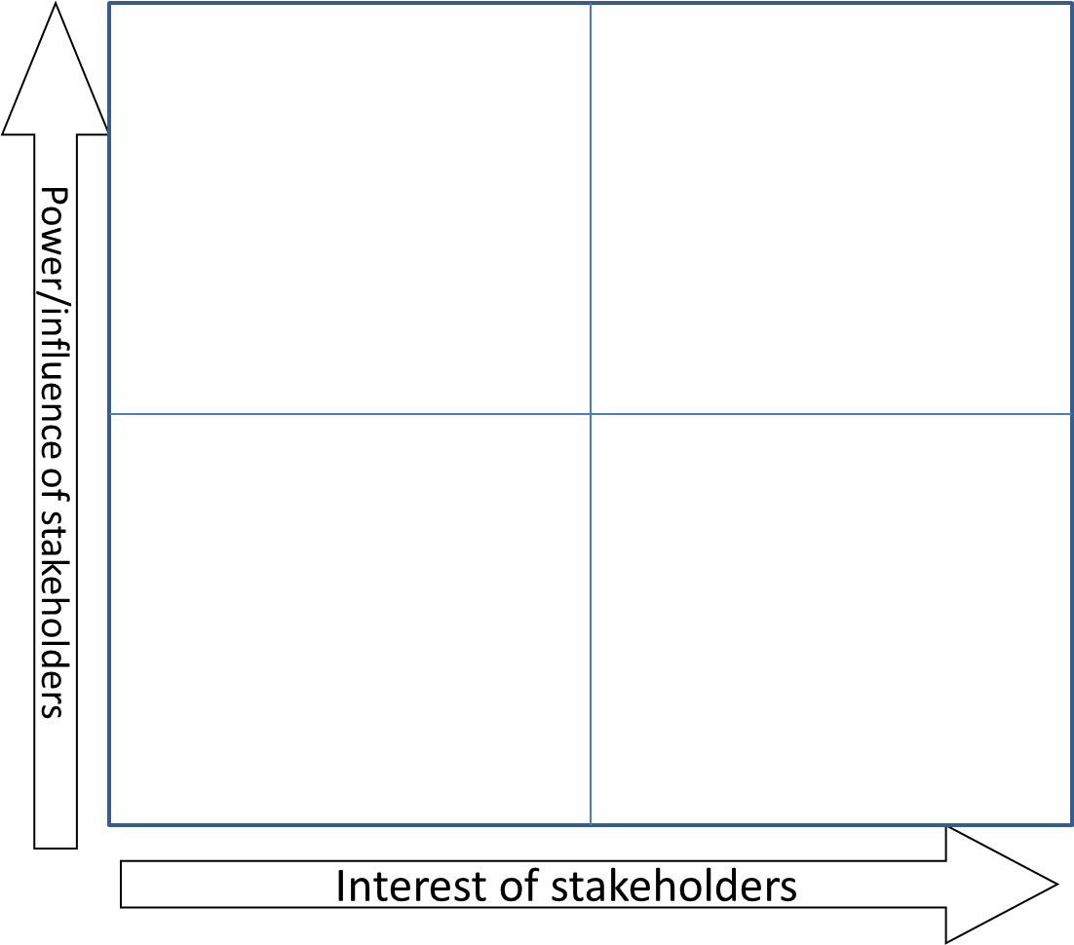

**Question 2:**

From the discussion with the Director what do you think are the strategic drivers of the library?

**Question 3**: How would you assess the success of the system given these drivers?

**Question 4:** Are there any principles or constraints the system must conform to?

**Question 5:** What do you think are the requirements of the library members?